Design and Implementation of a Low-Power ECG Simulator

Pragnya Chowdary Memparala Department of Electronics and Communication Engineering Vellore institute of technology
Vellore,India
memparala.pragnya2024@vitstudent.ac .in
Sagar Paresh Kumar Raman Bhai Department of Communication Engineering
Vellore institute of technology
Vellore,India
Pareshkumar.sagar@vit.ac.in

Brunda Sri Budda Department of Electronics and Communication Engineering Vellore institute of technology
Vellore,India
budda.brundasri2024@vitstudent.ac.in
Rakesh Kandibanda
Department of Electronics and Communication Engineering Vellore institute of technology
Vellore,India
kandibanda.rakesh2024@vitstudent.ac.in

Abstract - Biomedical signal acquisition and processing are crucial in modern healthcare diagnostics; thus, the electrocardiogram is an important tool used in cardiac health diagnosis. Still, conventional ECG systems are often bulky, expensive, and not suitable for portable or continuous monitoring. In this context, this paper is going to discuss the design and implementation of a low-power ECG conditioning system by using AD8232 analog front-end module along with Arduino UNO. The proposed system captures PQRST waveforms in a three-electrode configuration, plots signals using the Arduino Serial Plotter, and uses the moving average filter for signal clarity. The proposed technique provides a cost-effective, low-power approach toward portable and wearable ECG monitoring.
Keywords - ECG, Biomedical Signal Conditioning, AD8232, Arduino, Low Power, Wearable Healthcare.

INTRODUCTION

Understanding and diagnosing the physiological and pathological conditions of the human body depends heavily on biomedical signals. Since it shows the heart's electrical activity over time, the electrocardiogram (ECG) is one of the most significant and frequently used biomedical signals.[1]. Healthcare practitioners can identify and track a number of cardiovascular conditions, including arrhythmias, myocardial infarction, and ischemia, by examining ECG waveforms.[2]. Additionally, continuous ECG monitoring offers useful information for fitness evaluation and preventative healthcare.[3].
An ECG signal has a frequency spectrum that spans from 0.05 Hz to 150 Hz and is low amplitude, usually falling between 0.5 mV and 5 mV.[4]. The ECG is extremely vulnerable to various forms of noise and interference because of its small amplitude. Power-line interference (50/60 Hz), motion artifacts from electrode displacement, baseline wander from breathing, and electromyographic (EMG) noise from muscle contraction are common sources of noise.[5]. These noise components have the potential to significantly skew the signal, which could result in incorrect data interpretation or diagnosis. Therefore, to obtain a clean, noise-free ECG signal prior to digitization, effective analog signal conditioning—which includes amplification, filtering, and appropriate biasing—is necessary.[6].
Conventional ECG acquisition systems are usually constructed with discrete analog components, including right-leg drive (RLD) circuits (for common-mode noise cancellation), high-pass and low-pass filters (for noise removal), and instrumentation amplifiers (for differential amplification of the small ECG signal).[7]. Despite their effectiveness, these designs' large size, high power consumption, and complexity restrict their use in battery-operated or portable applications.[8]. Furthermore, the requirement for exact component matching and arrangement raises the complexity and cost of the design.[9].
An integrated and portable solution to these problems is offered by the AD8232 ECG sensor module.[1],[6],[10]. It combines lead-off detection circuitry, high-pass and low-pass filters, and an instrumentation amplifier onto a single chip. This preserves high signal integrity while drastically lowering board area, component count, and circuit complexity. For additional digital processing and display, the AD8232 module's clean analog output can be directly interfaced with the Analog-to-Digital Converter (ADC) of a microcontroller.[2],[5].
The Arduino Uno is a perfect platform for quick biomedical device prototyping because of its open-source environment, user-friendly interface, and integrated 10-bit ADC. [3],[4]. An inexpensive, portable ECG monitoring device that can record, display, and process heart signals in real time can be created by combining the AD8232 module with Arduino. [6],[7]. These systems are useful for home-based patient monitoring, telemedicine applications, wearable medical technology, and laboratory and educational settings. [8],[9],[11].
An Arduino-based low-power analog front-end system for ECG signal acquisition using the AD8232 sensor module is designed, implemented, and its performance evaluated in this work. The main issues with noise reduction, low-amplitude signal acquisition, and microcontroller platform compatibility are the main targets of the suggested system. [1],[5],[10]. The outcomes show that the system offers a dependable and effective way to monitor accurate ECG in real time. [2],[3],[6].
The remainder of this paper is organized as follows: Section II presents a review of related works and discusses the research gap. Section III defines the problem statement and identifies the objectives. Section IV details the methodology, experimental setup, and circuit design. Section V discusses the results obtained from prototype testing and performance evaluation. Section VI concludes the paper and outlines possible directions for future work. Section VII lists the references used in formulating this study.

Literature Review

Designing low-power and reliable ECG acquisition systems needs careful attention to the analog front-end, electrode interface, and successive digital processing. The AD8232 is a dedicated single-lead analog front-end specifically designed to integrate an instrumentation amplifier with a right-leg drive and built-in filtering and lead-off detection; hence, simplifying front-end design in portable ECG applications and reducing circuit complexity and power consumption
Many prototypes and academic implementations have exploited the AD8232 for low-cost, portable ECG instruments. Bravo-Z et al. demonstrated a portable ECG device that used the AD8232 evaluation hardware combined with open-source microcontrollers to create a PCB prototype suitable for long-term monitoring, and in so doing showed that the AD8232 can form the core of a compact single-lead recorder.
Practical tutorials and maker resources have made the AD8232 + Arduino/Arduino-Nano combination a popular rapid prototyping platform for education and proof-of-concept ECG capture and visualization. Such resources highlight real-world considerations, including electrode placement, lead-off detection, and the need for simple digital filtering to expose the P, QRS, and T features.
The broader field of wearable ECG and health monitoring is based on tradeoffs among power, form factor, and signal quality. Recent reviews of wearable ECG systems present a trend for the integration of low-power AFEs, power-efficient microcontrollers or SoCs with wireless, and on-device preprocessing to save battery life without a compromise of diagnostic fidelity. The common challenges reported in various works include motion artifacts, muscle (EMG) interference, and 50/60 Hz power-line noise-all requiring a combination of hardware filtering by AFE design, shielding, and electrode contact along with software algorithms like adaptive filtering and baseline wander removal.
More recent works extend low-cost ECG prototypes with wireless telemetry and cloud-based analytics. Several groups have demonstrated AD8232-based wearable recorders that stream ECG to smartphones or cloud servers (often using ESP32/Bluetooth) and apply machine-learning models for arrhythmia detection on the backend, illustrating a feasible path from single-lead acquisition to automated diagnosis in remote settings. These studies also underscore the importance of data quality for robust ML performance (signal-to-noise ratio, accurate PQRST labeling).
Gap analysis: though many published prototypes and tutorials confirm that AD8232 + Arduino is an accessible and low-power solution for single-lead ECG, the literature still reflects variability in the way researchers handle motion artifacts, electrode robustness, and low-amplitude P/T wave preservation in portable setups. A few low-cost studies report quantitative power-consumption measurements together with objective signal-quality metrics (SNR, PQRST detection sensitivity) under realistic ambulatory conditions. This motivates our work to (1) evaluate signal conditioning and filtering approaches that better preserve the P and T morphology on a low-power platform and (2) report both the signal-quality metrics and power budgets for the prototype.
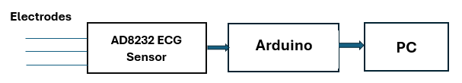

Fig. 1. Typical low-power ECG signal Simulator

Problem Statement and Research Gap

However, even though there are significant advances in the design and implementation of low-power ECG simulators, a number of factors still limit practical applicability. Most state-of-the-art simulators have limited arrhythmia detection capability since they are usually configured to mimic only a few kinds of cardiac abnormalities. This reduction diminishes the comprehensiveness of testing or evaluation in healthcare applications. Secondly, ultra-low power consumption has remained a challenge.
Most of the existing designs, while optimized for portable or wearable applications, still consume more energy than is desirable for continuous monitoring, which in turn affects battery life and long-term wearability. Integration with IoT platforms introduces added complexity, especially in the reliable transmission of real-time data, its processing, and storage, while keeping energy consumption at low levels. Some ECG simulators also lack real-time signal processing capabilities, which are important for quick diagnosis and intervention during clinical scenarios.
Such limitations further indicate multiple research gaps in the process. The first relates to the need for low-power ECG models that should ensure high accuracy in the detection of a wide spectrum of arrhythmia. Recent studies have proposed new machine learning techniques, such as lightweight transformer models, which are promising solutions given their high detection accuracy with very low computational overhead.
Second, improved data compression can reduce storage and energy needs while maintaining signal fidelity; however, its use in low-power simulators is still at a premium. Third, AI integration has the potential to greatly enhance the diagnostic functionalities of ECG simulators, allowing for automated and highly accurate arrhythmia classification. Finally, due to the lack of standardized data formats across simulators and monitoring systems, interoperability remains low, thus limiting scalability and wider adoption in healthcare settings. Resolving these deficiencies will be key to the future creation of low-power ECG simulators that are efficient, accurate, and deployable on a large scale.

IV.METHODOLOGY

The proposed low-power ECG simulator will acquire, process, and visualize cardiac signals by using the AD8232 ECG sensor and Arduino Uno microcontroller. The system is optimized for low power consumption, portability, and accurate representation of the PQRST waveform.

System Design:
The system architecture consists of three main components: the ECG signal acquisition module, the microcontroller-based processing unit, and the data visualization interface. The AD8232 acts as a front-end signal conditioning module that captures biopotential signals via standard ECG electrodes fixed on the subject's body. The sensor filters out high-frequency noise, motion artifacts, and baseline drift while amplifying the low-level cardiac signals to an amplitude range compatible with the Arduino's analog-to-digital converter.
The Arduino Uno acts as the processing unit: it digitizes the analog ECG signal, provides some basic filtering, and sends data to the host PC or display module. The system has a 5 V supply to ensure low energy consumption for any kind of portable device. The overall block diagram of the system is represented below in Fig. 1: AD8232 → Arduino Uno → PC visualization.

AD8232 ECG Sensor:
The AD8232 is a compact, integrated analog front-end module designed for single-lead ECG measurements. Its key features include:
1. CMRR (Common-Mode Rejection Ratio) should be high: Reduction of interference from other sources, such as power lines.
2. Right-Leg Drive Circuitry: Reduces common-mode voltages, enhancing the signal quality.
3. Low Power Consumption: Ideal for wearable and portable devices.
4. Leads-Off Detection: Ensures correct electrode placement and warns if electrodes lose contact.
Three electrodes such as right arm (RA), left arm (LA), and right leg (RL) are placed on the subject's body according to conventional ECG positioning. The AD8232 gives out a conditioned analog signal representing the ECG waveform.
5. Integrated Amplification and Filtering: A clean, conditioned analog ECG output is produced by the internal amplifier and filter stages, which eliminate baseline wander and high-frequency interference.
6. Single-Supply Operation: Makes circuit design simpler and ensures compatibility with microcontrollers by operating efficiently from a single low-voltage supply (usually 3.3 V).
7. ECG waveform monitoring and analysis are made possible by the module's small size and standard pin configuration, which enable smooth interaction with development boards like Arduino.
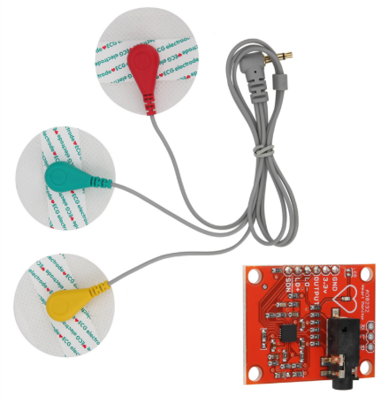
Fig.2. AD8232 ECG Sensor

Arduino Uno Microcontroller:
ECG signal digitization and processing is carried out using Arduino Uno, based on the ATmega328P microcontroller. The main functions are:
- Analog to Digital Conversion: Sampling of ECG signal at 250–500 Hz for PQRST wave components with good accuracy.
- Signal Filtering: Basic digital filtering, such as moving average or low pass, to remove residual noise.
- Data Transmission: The sampled data is sent to a PC for visualization using the serial port.
- Real-Time Visualization: Visualize ECG waveforms in real time using the Arduino IDE serial plotter or writing custom software for the purpose.
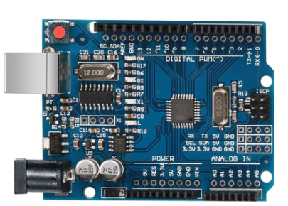

Fig.3. Arduino UNO Microcontroller Board

Data Acquisition Strategy:
Data acquisition involves continuous monitoring of the analog ECG output from the AD8232. Arduino's 10-bit ADC reads out the analog voltage with a resolution of 1024 discrete levels, which is sufficient for capturing the fine details in the PQRST complex. The steps to acquire data include the following:
- Initialize the Arduino ADC and serial at 115200 baud rate.
- 2. Sample the analog signal at a fixed interval to ensure a uniform sampling rate, for example, 500 Hz.
- 3. Use basic digital filtering in the microcontroller to reduce high-frequency noise.
- 4. Store or transmit the digitized ECG data to a PC for plotting and further analysis.
- 5. Monitor the lead-off detection pin from AD8232 to ensure reliable electrode contact throughout acquisition.
This strategy ensures the effective acquisition of ECG signals with high accuracy and continuity, with low computational overhead and power consumption. The methodology provides a robust basis for real-time cardiac monitoring, testing of ECG algorithms, and validation of low-power analog front-end designs.

Hardware setup:
The hardware setup for ECG acquisition involves integrating the AD8232 ECG sensor module with the Arduino Uno microcontroller for capturing and processing the electrical signals generated by the heart. The AD8232 is a low-power single-lead ECG front-end specifically designed for wearable and portable applications. It has a compact design that makes it easy to interface with a microcontroller such as Arduino.
The AD8232 module normally has 6 pins:
- 3.3V or 5V (VCC): Power supply pin connected to Arduino 3.3V or 5V
- GND: Ground reference connected to Arduino GND.
- OUTPUT (ECG): Analog output of ECG signal, connected to Arduino analog input; for example, A0.
- LO+ (Leads Off Positive): Detects the disconnection of electrodes; connected to the digital input pin on Arduino.
- LO−: Leads Off Negative Detects disconnection of electrodes. Connected to digital input pin on Arduino
- SDN (Shutdown, optional): To enable/disable the sensor. It should be connected to Logic HIGH or LOW depending on the mode of operation.

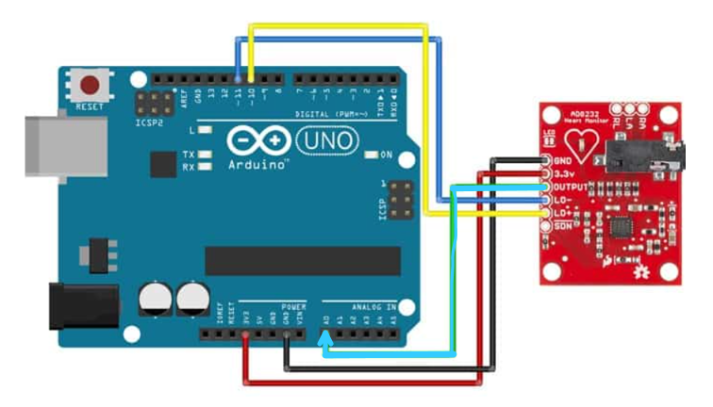

Fig.4. Hardware Connection Diagram

Electrode Placement:
For single-lead ECG acquisition:
- Right Arm (RA): Connect to electrode on the right wrist or right chest.
- Left Arm (LA): Connect to electrode on the left wrist or left chest.
- Right Leg (RL) / Reference: Attach to the electrode on the lower torso or leg to stabilize the baseline.
RA, LA, and RL pins of the AD8232 sensor are connected to electrodes correspondingly. Good contact with skin and low impedance are very important for minimizing noise and artifacts.

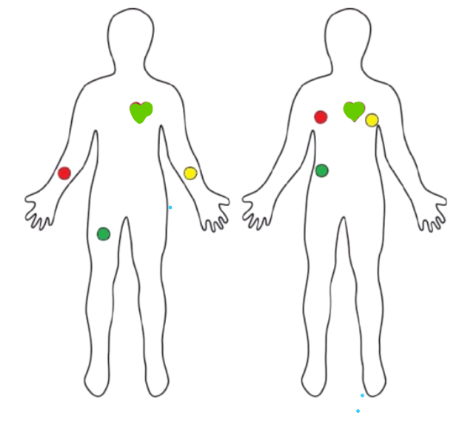
Fig.5. Electrodes placement on human body

The analog ECG signal from the sensor is read through the ADC (10-bit resolution, 0–5 V) of the Arduino Uno. The sampled data, after this, can be further processed, filtered, or even visualized with the Arduino IDE serial plotter. Leads-off pins allow real-time monitoring of electrode connectivity to avoid erroneous readings.
This setup enables a compact, low-power, and reliable ECG acquisition system suitable for portable health monitoring applications.

V. Results
A. ECG Waveform Characteristics:
The ECG obtained from the AD8232 sensor interfaced with Arduino Uno showed a characteristic PQRST waveform, which represents the electrical activity of the heart. The captured signal provides essential clinical information, as outlined below:
- P Wave: This corresponds to the atrial depolarization. A small, rounded deflection seen before the QRS complex shows that the atrial activity has been correctly detected.
- QRS Complex: This is representative of ventricular depolarization. A sharp and prominent deflection was seen in the recorded waveform-an indication that the system is capable of capturing rapid changes in cardiac electrical activity.
- T Wave: This is associated with ventricular repolarization. A wider, smoother deflection after the QRS complex was recorded, which proved that AD8232 was suitable for the acquisition of low-frequency cardiac activities.
- PR and ST Intervals: The P–QRS and S–T segments were well delineated, allowing for the clear measurement of the timing parameters of cardiac cycles.
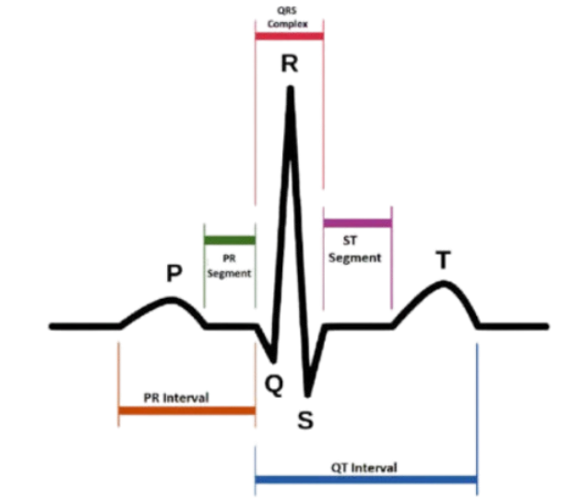
Fig.6. PQRST wave

In this work, a prototype ECG acquisition system is implemented using an integrated AD8232 analog front end and an Arduino microcontroller. The raw analog output of the AD8232 was digitized through the Arduino's 10-bit ADC and transmitted to a PC for visualization using the Arduino Serial Plotter.
During experimentation, the system generated a stable baseline voltage of about 1.6 V, or 330 ADC counts at a reference of 3.3 V-the internal DC offset of the AD8232. Baseline correction and further digital amplification allowed the prototype to extract the dynamic ECG waveform centered around this baseline. The acquired waveform had characteristic variations with respect to the P-Q-R-S-T complex; however, the amplitude and sharpness of each peak were affected by electrode placement, quality of skin-electrode contact, and the surrounding noise.
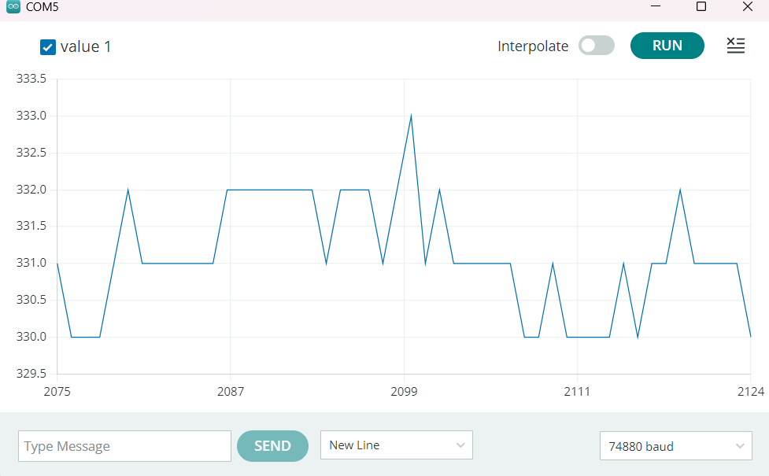
Fig.7. Resultant graph
Figure 7shows a simulated electrocardiogram (ECG) signal with time-varying amplitude fluctuations that match distinct cardiac cycle phases. The horizontal axis shows time in discrete samples, and the vertical axis shows the simulated signal amplitude (arbitrary units). In order to simulate real-world heart-rate fluctuations and measurement noise, this artificial signal exhibits characteristics like dynamic baseline, rapid peaks (similar to QRS complexes), and interval variability. Robust algorithmic validation and assessment of noise resilience in biomedical instrumentation were made possible by the simulation's execution with adjustable parameters for signal interpolation and sampling.
Figure 8 shows a representative output from the prototype, where baseline drift was minimized through a moving average filter. The QRS complex was observed as a sharp positive deflection (R-peak), followed by negative excursions corresponding to the S-wave. Smaller deflections corresponding to P and T waves were also visible, though less pronounced due to system noise and the limitations of single-lead acquisition.

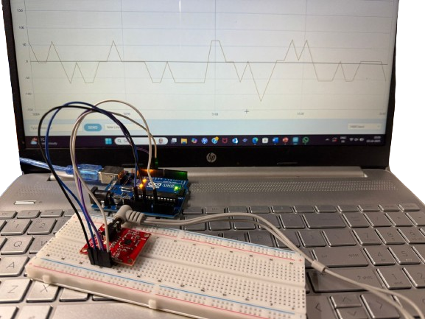
Fig.8. Hardware Setup

As a whole, the prototype proved the feasibility of ECG monitoring that is affordable and portable using widely available hardware. The signals observed validate the capability of the AD8232–Arduino system to capture essential cardiac activity and form a foundation for which further refinement could be implemented, such as advanced filtering and wireless data transmission.

VI. CONCLUSION
In this work, we designed and prototyped a low-cost, single-lead ECG monitoring system using the AD8232 analog front end and an Arduino microcontroller. The system acquires raw biopotential signals, digitizes them via the Arduino's 10-bit ADC, and transmits them to a PC for visualization and further signal processing (baseline removal, amplification, peak detection). The prototype demonstrated detection of QRS complexes in the ECG waveform in a controlled setting, whereas P and T waves were of lower amplitude and occasionally obscured by noise and baseline drift. These results validate the feasibility of ECG acquisition using open-source, low-cost hardware.
However, in real conditions, motion artifacts, electrode contact quality, and environmental interference degrade the quality of the signal. Diagnostic capability is constrained due to a single-lead configuration compared to multi-lead ECGs. Future improvements may include better analog filtering, adaptive digital filtering, wireless transmission via Bluetooth or Wi-Fi, multi-lead acquisition, and embedding real-time arrhythmia detection algorithms.
Overall, this prototype forms a viable proof-of-concept for portable, low-cost ECG monitoring systems that could be useful in telehealth, wearable health monitoring applications, and resource-poor medical environments.
VII.REFERENCES

- S. Prasad and N. Kavana Shree, "ECG Monitoring System Using AD8232 Sensor," 2019 International Conference on Communication and Electronics Systems (ICCES), Coimbatore, India, 2019, pp. 976-980, Doi:10.1109/ICCES45898.2019.9002540.
- S. R. Dasarapalli, R. K. Panneerselvam, S. Annavarapu and K. R. Gopireddy, "Three-Lead ECG and Heartrate Variability Using AD8232," 2023 14th International Conference on Computing Communication and Networking Technologies (ICCCNT), Delhi, India, 2023, pp. 1-6, Doi: 10.1109/ICCCNT56998.2023.10306769.
- M. M. Rahman, M. A. H. Rimon, M. A. Hoque and M. R. Sammir, "Affordable Smart ECG Monitoring Using Arduino & Bluetooth Module," 2019 1st International Conference on Advances in Science, Engineering and Robotics Technology (ICASERT), Dhaka, Bangladesh, 2019, pp. 1-4, Doi: 10.1109/ICASERT.2019.8934498.
- H. Güvenç, "Wireless ECG Device with Arduino," 2020 Medical Technologies Congress (TIPTEKNO), Antalya, Turkey, 2020, pp. 1-4, Doi: 10.1109/TIPTEKNO50054.2020.9299248.
- N. M. Narasinghe, C. P. Obeng and R. Striker, "valuating Low-Cost Alternatives in ECG Front-End Systems: A Performance Comparison of AD8232 with High-End BIOPAC MP160," 2025 IEEE International Conference on Electro Information Technology (eIT), Valparaiso, IN, USA, 2025, pp. 591-596, Doi: 10.1109/eIT64391.2025.11103617.
- Dange, S. Ruikar, S. Kadam, R. Sidanale, S. Sangwai and S. Sadake, "Portable ECG Monitoring System Using AD8232 and ESP8266," 2024 International Conference on Artificial Intelligence and Quantum Computation-Based Sensor Application (ICAIQSA), Nagpur, India, 2024, pp. 1-6, Doi: 10.1109/ICAIQSA64000.2024.10882371.
- M. Anandan, M. K. Mishra, P. Veluswamy and R. Palanisamy, "Implementation and Analysis of Wireless ECG Signal Conditioning Circuit for Smart Healthcare Solution," 2023 IEEE 7th Conference on Information and Communication Technology (CICT), Jabalpur, India, 2023, pp. 1-6, doi: 10.1109/CICT59886.2023.10455591.
- C. N. Nurbadriani, M. Melinda, Y. Yunidar and F. Arnia, "Electrocardiogram Detection System of Autistic Children Based on AD8232 for Healthcare," 2023 2nd International Conference on Computer System, Information Technology, and Electrical Engineering (COSITE), Banda Aceh, Indonesia, 2023, pp. 126-131, Doi: 10.1109/COSITE60233.2023.10250117.
- S. Poomdla, J. A. John, P. K. Kandregula, R. Murrieta, K. George and A. Panangadan, "Integration of Multiple Sensor-Based Wellness Systems for Supportive Housing Using Bluetooth Low Energy," 2024 IEEE 6th Eurasia Conference on Biomedical Engineering, Healthcare and Sustainability (ECBIOS), Tainan, Taiwan, 2024, pp. 406-411, doi:10.1109/ECBIOS61468.2024.10885512.
- N. Goel, S. Bhatia and P. Rana, "Secure Smart Devices Control with Low Power Consumption," 2023 3rd International Conference on Advancement in Electronics & Communication Engineering (AECE), GHAZIABAD, India, 2023, pp. 83-87, doi: 10.1109/AECE59614.2023.10428213.
- V. B. Guimarães, F. Z. Righi, C. Müller, P. C. C. d. Aguirre and A. G. Girardi, "Analog Front-End for ECG Signal Acquisition with Automatic Gain Control," 2025 9th International Symposium on Instrumentation Systems, Circuits and Transducers (INSCIT), Manaus, Brazil, 2025, pp. 1-6, doi: 10.1109/INSCIT66472.2025.11181022.
- A. Dixit, A. Kumar, S. Shukla and G. Srivastava, "Electronically Tuneable Low Power Cascaded OTAC Fifth Order Notch Filter for Front End ECG Processing System," 2024 5th International Conference on Smart Electronics and Communication (ICOSEC), Trichy, India, 2024, pp. 397-403, doi: 10.1109/ICOSEC61587.2024.10722443.
- T. Mamee, P. Manorost, C. Chamroon and K. Thunsiri, "Comparative Analysis of AD8232 and BioAmp EXG Pill Analog Front-End Devices in ECG Signal Processing," 2023 IEEE 11th Conference on Systems, Process & Control (ICSPC), Malacca, Malaysia, 2023, pp. 252-257, doi: 10.1109/ICSPC59664.2023.10420266.
- B. Mishra and P. Patel, "Energy Harvester Powered Fully Digital ECG Front End Acquisition with Integrated TDC," 2023 IEEE Asia Pacific Conference on Circuits and Systems (APCCAS), Hyderabad, India, 2023, pp. 328-332, doi: 10.1109/APCCAS60141.2023.00080.
- S. Zhu and Y. Wang, "A 1.8V, SNDR 96.3dB analog front-end circuit design for ECG signal acquisition," 2024 6th International Conference on Natural Language Processing (ICNLP), Xi'an, China, 2024, pp. 742-746, doi: 10.1109/ICNLP60986.2024.10692516.
- A. Stanešić, L. Klaić, D. Cindrić and M. Cifrek, "Analog Front End for Capacitive Electrodes in Biomedical Applications," 2025 MIPRO 48th ICT and Electronics Convention, Opatija, Croatia, 2025, pp. 1299-1302, doi: 10.1109/MIPRO65660.2025.11131710.
- Guermandi, M., Benatti, S., & Benini, L. (2024). A Noncontact ECG Sensing System With a Micropower, Ultrahigh Impedance Front-End, and BLE Connectivity. IEEE Sensors Journal, Sensors Journal, IEEE, IEEE Sensors J, 24(4), 4609–4617, doi: 10.1109/JSEN.2023.3347100
- Iliev, I., Nikolov, G. T., Tomchev, N., Stefanov, B. I., & Tzaneva, B. (2025). Design and Assessment of Flexible Capacitive Electrodes for Reusable ECG Monitoring: Effects of Sweat and Adapted Front-End Configuration. SENSORS, 25(18), 5856, doi: 10.3390/s25185856
- Iliev, I., Nikolov, G. T., Tomchev, N., Stefanov, B. I., & Tzaneva, B. (2025). Design and Assessment of Flexible Capacitive Electrodes for Reusable ECG Monitoring: Effects of Sweat and Adapted Front-End Configuration. SENSORS, 25(18), 5856, doi- 10.3390/s25185856

